ARTIFICIAL INTELLIGENCE LAB
Task 1
Minimax Trace By Hand
Course | CAI601400 - Artificial Intelligence Lab
Student Name | Uzair Alam
Roll Number | Su92-Bssem-S25-052
Submission Date | 24 October 2026
Submission To | Rasikh Ali
Prepared from the requirements in the Lab 4 manual

Contents
Minimax Trace By Hand 3
Trace 3

Minimax Trace By Hand
Minimax is used in two-player games. One player is MAX and tries to get the highest score. The other player is MIN and tries to get the lowest score. The leaf values are known, and the values are passed up the tree from the bottom to the root. The given tree has three levels: MAX at the root, MIN in the middle and MAX at the bottom.
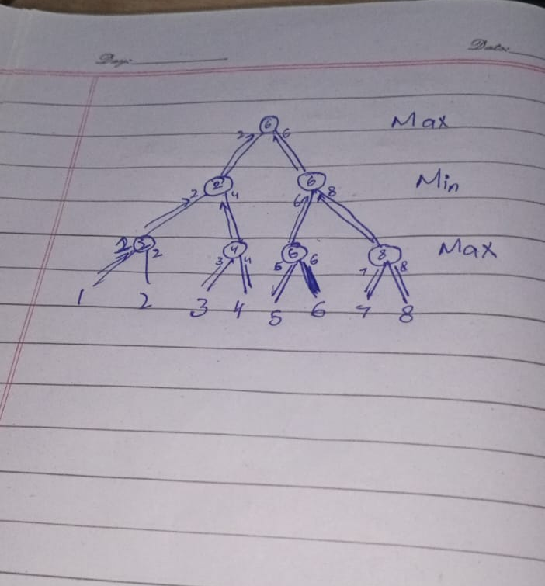

Trace
Step 1: The bottom MAX nodes take the highest value of their leaves.
- Leaves 1 and 2 give 2.
- Leaves 3 and 4 give 4.
- Leaves 5 and 6 give 6.
- Leaves 7 and 8 give 8.
Step 2: The MIN nodes take the lowest value of their children.
- Left MIN node: min(2, 4) = 2.
- Right MIN node: min(6, 8) = 6.
Step 3: The root is a MAX node, so it takes the highest value of its children.
- Root: max(2, 6) = 6.

